Interactive Construction of Mobile Agents

A joint submission to DARPA SBIR 99.2-45
by The Open Group Research Institute and JXML, Inc.

Cover Sheet (Appendix A)

Project Summary (Appendix B)

Identification and Significance of Problem or Opportunity
This proposal describes a software research and advanced development project that will demonstrate the feasibility of providing a toolkit that will allow users of the toolkit to dynamically compose, deploy, and modify trustable software agents. This approach, called Interactive Construction of Mobile Agents, will allow end users to rapidly and easily construct powerful software agents by describing the agent intent (the expected actions the agent will take at runtime) in a human-readable text-based XML format. These intents will be passed to the target system, transformed into an implementation specific to that target system, and executed by the agent platform.
A technology called Coins, under development by the PI, forms the underlying technology for this proposal. Coins provides for the collaborative implementation of robust multi-tier distributed applications. Coins builds on both XML and Java, using XML documents to define the agents which move between systems, and using Java components to implement those agents within various clients and servers.
Coins supports multiple application-specific markup languages for the expression of agents, including references to other documents which can be retrieved by URL. Using Coins as a foundation, agents are webs of interconnected documents, with the main body of the agent being pushed to the agent's destination, the remainder being pulled in by the runtime when the agent is instantiated as a structure of Java components. This arrangement allows the largest part of an agent to remain static, cached, and sharable with other agents.

Problem Description
Our approach is intended to address the following problems, which are experienced by traditional static approaches to agent technologies in real-world deployment situations:

Footprint requirements need to be minimal, both on clients and on front-end servers connected with instrumentation packages.

Agent generation should depend on current situational requirements.

Agent technology is inherently unsafe and requires a security model that addresses this in a form that is scalable on the server side while also protecting the client.

Agent intent must be visible to enable forwarding of agent to new information sources as they become available.

Agent behavior on the server (destination) side is dependent on the structure of the server and the information available within that server.

Technical Approach: Coins and MDSAX
As noted in the introduction to section C, our approach is based on a technology called Coins, which combines the capabilities of XML and Java. We will use XML documents, which are used to convey the intent of the agents, which move between systems, and an execution context definition, called ContextML, and associated Java components to implement those agents within various clients and servers. Since the intent descriptions are in XML, they can be transmitted to the target execution environment via any protocol that is capable of transmitting text messages, e.g., email, http, and ftp.
Coins provides a small-footprint runtime environment which supports multiple application-specific markup languages for the expression of agents. These expressions can include references to other documents that can be retrieved by URL.
Due to the ability of Coins to assemble components dynamically, agents can then be viewed as webs of interconnected documents, the main body of the agent being pushed to the agent's destination, with the remainder being pulled when the agent is implemented as a structure of Java components. This arrangement allows the largest part of an agent to remain static, cached, and sharable with other agents.
A Java component here is simply a broadening of the JavaBean concept. Coins makes use of the various design patterns defined by JavaBeans, but without the requirement for Serialization. The Coins technology fully supports existing JavaBeans.
MDSAX is a tool for implementing Coins. MDSAX uses the Simple API for XML (SAX) http://www.megginson.com/SAX. MDSAX works with any number of XML parsers that support SAX, including AElfred http://www.microstar.com/aelfred.html and IBM's XML4J http://www.alphaworks.ibm.com/formula/xml.
MDSAX is a toolkit for building engines to transform XML documents. These engines typically produce a composition of Java components. (A composition here means that a number of Java objects have been created, initialized, and wired together.)
ContextML is an XML markup language used to define an MDSAX engine. MDSAX itself is an engine for transforming ContextML documents into engines. In practice, MDSAX has a hard-coded engine that can only transform a simplified version of ContextML. The full version of ContextML is then defined in a bootstrap XML document using this simplified version. Transforming this bootstrap document yields an engine that can be used to transform documents that exploit the capabilities of the full version of ContextML. In addition to reducing the size of the engine, this indirect approach has the added benefit of making ContextML fully extensible.
A key concept here is the use of application-specific markup languages to transfer data and agents between clients and servers. A single MDSAX engine is capable of validating and transforming more than one markup language, which allows for a rich protocol. The engine can validate both the data and the structure of the document being processed, to assure that the document is safe to process. And the engine itself determines the components to be used when composing from the document, so that the document itself is independent of the implementation of the client or server that received the document. With the target user automatically validating the XML-based intent documents before execution, there is a built-in defense against Trojan-horse security attacks. Since no executable Java Beans accompany the intent, the user is further protected against the spread of virus-bearing code.
A second key concept is that the agents are transformed into executable structures of components. As part of the transformation, the engine can interconnect this structure with components that are part of the receiving client or server, which allows the agent to access and alter the client or server.

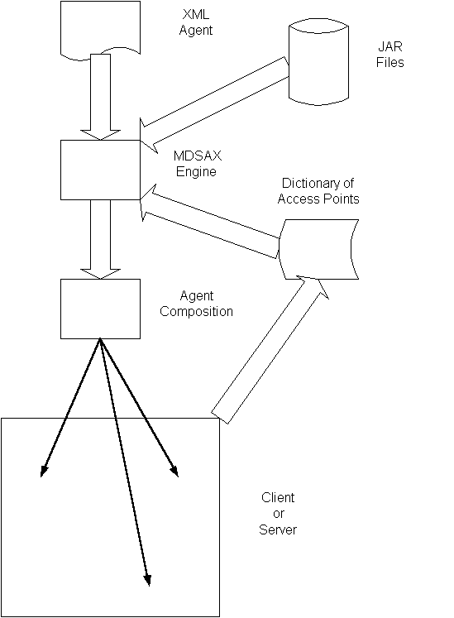
The above diagram shows the composition of an agent by the MDSAX engine, using an XML file and a local JAR file. The agent is given access to various parts of the receiving client or server, as specified in the dictionary created by that client or server.
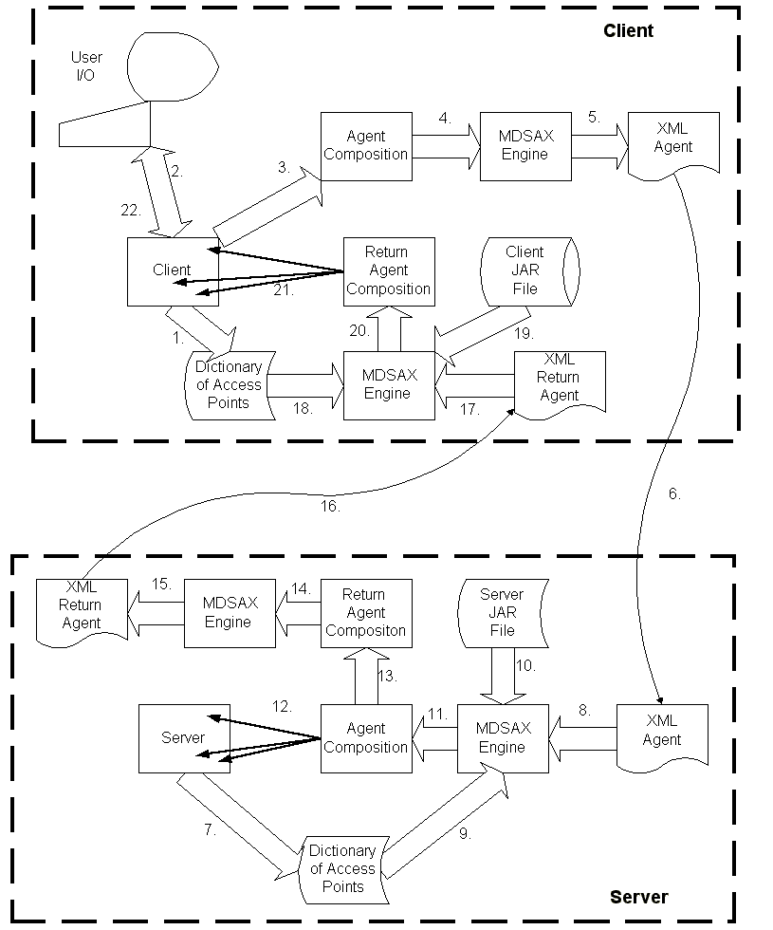
The above diagram shows the interactive creation of an agent, the agent's remote execution, and an update to the display based on the results of that execution, as follows:
- During initialization, the client application establishes various internal points of access to be made available to incoming/returning agents.
- The user interacts with the client application, requesting a remote service.
- The client application defines the remote service request using one or more objects.
- The objects defining the remote service request are passed to the MDSAX engine for processing.
- The MDSAX engine walks the object graph, extracts selected information, and produces an XML document which describes the intent of the remote service request.
- The XML document is passed from the client system to the server system.
- During initialization, the server application establishes various internal points of access to be made available to incoming/returning agents.
- The XML document is passed to the MDSAX engine for processing.
- The MDSAX engine inserts references to various parts of the server application into the agent being composed.
- The MDSAX engine composes the agent from the server's own classes.
- The MDSAX engine passes control to the agent it just created.
- The agent interacts with the server, performing a query, update, or some other operation.
- The agent constructs a response in the form of one or more objects.
- The objects defining the response are passed to the MDSAX engine for processing.
- The MDSAX engine walks the object graph, extracts selected information, and produces an XML document that describes the returning agent.
- The XML document is passed from the server system back to the client system.
- The XML document is passed to the MDSAX engine for processing.
- The MDSAX engine inserts references to various parts of the client application into the agent being composed.
- The MDSAX engine composes the agent from the client's own classes.
- The MDSAX engine passes control to the agent it just created.
- The agent interacts with the client, updating the client with the results of the remote operation.
- The user's display is updated appropriately.

Benefits
A full instantiation of our proposed combination of Java, XML and the Coins architecture will provide the following benefits to deployed systems:

Intent is separate from implementation⎯one intent will work across multiple execution environments. This allows both backward compatibility with existing systems and datasets and simplified maintenance systems during deployment.

Intent is descriptive, therefore fully validatable⎯this allows for secure operation. The intent can be checked for safety. No implementation code is transmitted, which eliminates the threat of viruses and Trojan horse attacks inherent in traditional agent systems.

Since no code is transmitted, and intent can be validated on arrival, there is no need for a safe zone or "sandbox" for agent execution. This removes one of the significant sources of slowdown in existing mobile code approaches.

Dynamic composition driven by user intent⎯the agent pulls in only the implementation needed for mission, resulting in a small footprint for agent environment. This is necessary for the deployment of agents in resource-limited but critical systems such as mobile/handheld/ embedded control or legacy computing systems. Use of these smaller-footprint systems reduces system deployment costs, as does elimination of the need to replace legacy systems.

Dynamic composition is also extensible after deployment. Additional capabilities can be added to the runtime as agent sophistication or data complexity grows. This means the system will not become obsolete over time, thus lowering lifecycle costs by reducing the need for equipment upgrades.

Phase I Technical Objectives

Development of a prototype GUI-driven Agent Generation tool
We will create an agent platform, and an example configuration that will demonstrate the interactive generation of agents and the results of the agent's remote execution via a graphical interface.

Development of example Data Integration Agents
We will enhance the previous example agent to include access to external data, such as an ODBC or SQL database.

A proof-of-concept Intent Validation tool
We will demonstrate that the agent platform validates the fields, data, and structure of the agent documents.

Phase I Work Plan
For phase I, we propose the following activities over a six month time span to determine the feasibility of the proposed approach:

Extend MDSAX data and content validation capabilities to provide greater assurance that agents entering a client or server are fully conformant to the requirements of the receiving system.

Augment MDSAX with a referential capability, giving agents entering a system access to internal resources specific to the receiving system.

Extend MDSAX compositional capabilities to provide better support for Java Swing components.

Design the complimentary extraction capability capable of walking arbitrary structures of application components defining an agent or response, while producing the XML document which constitutes the persistent and portable form of the agent.

Enhance ContextML, the extensible XML markup language which governs the behavior of the MDSAX engine, to include the information needed to produce XML documents by extracting selected data items from arbitrary structures of application components.

Extend the MDSAX engine with a new mode of operation, extraction, so that a ContextML document can be used to control both composition and extraction.

Demonstrate a server that accepts agents, performs a simple query or update, and then sends an agent back to the originator with the response.

Demonstrate a client which launches agents in response to various informational needs and which updates its display appropriately as agents are received. Demonstrate the ability of incoming agents to augment an active GUI when new information or resources become available.

Report on feasibility of Composable Agent concepts.

Report on feasibility of validation of Agents for trustability.
In addition to the technical feasibility reports noted above, we will have as monthly milestones the submission of a progress report, as well as maintaining ongoing contact with the program's technical monitor.

Related Work

Past JXML activities on XML, COINS and MDSAX
The Principal Investigator, Bill laForge, has been investigating the use of XML and Java as a method of implementing mobile agents and compositional programming for several years. He was the architect of a mobile agent development project in conjunction with The Open Group (see http://www.jxml.com/papers/coots2.pdf). In addition, he has both authored presentations (see http://www.jxml.com/coins/oldCoins/presentations/Coins981026/index.htm) and produced tools for compositional programming, notably MDSAX (http://www.jxml.com/mdsax/index.html).

Relationship with Future Research or Research and Development
Actual deployment of agents in a real world environment must cope with significantly increased scales of interactions with other agents and platforms. Future developments of the technology should include (1) a server that maintains information about other available servers, where agents forward themselves to the appropriate server(s) as determined by the intent of those agents, and (2) the ability of the receiving client to define the behavior of an incoming agent based on the current activities of the client. These capabilities will be targets of development in future phases.

Commercialization Strategy

Commercialization overview
Our approach to the problem consists of the deployment of innovative agent software based on emerging Internet standards, specifically XML and Java. As with most software products, the cost of manufacturing is negligible, with the majority of the commercialization costs occurring in marketing and channel development. Unfortunately, since there is by definition no pre-existing market for innovative approaches, the costs of marketing and channel development are both high cost and high risk. There is no sure road to rapid deployment of innovative software products.
To mitigate this issue, and to provide a high probability of commercial availability of the software without the costs of channel development and marketing, we propose a three-pronged approach. First, we will seek to work directly with one or more military programs to provide prototype technology in the context of that program. Second, we will make the foundation software available under an open source license. Third, we will pursue commercial partnerships and prerelease licensing opportunities with companies in relevant market areas.

Commercialization: Military Program Targets
The Open Group has long history of working on DARPA contracts in partnerships with military programs, particularly those in advanced development phases. Examples of involvement in research programs include DARPA High-Assurance Computing and Quorum programs. Examples of technology transfer include the Navy HiPerD program and the AWACS ATD program. These transfer activities included both the development of software incorporating innovative real-time and adaptivity features, and also close cooperation and support of the technology transfer targets. This support includes both custom development of software features as directed by the target, onsite training and support of the target personnel, and post-transfer defect support. Once the concepts in this proposal have been proven, we would seek likely military advanced development programs as targets for transfer to the proposed technology.

Commercialization: Open Source Distribution
The ultimate target consumer of this technology will be end users' in-house development and integration staff. The principal use will be for in-house integration of complex systems with differing datatypes needing conversion.
The proposed approach, when fully implemented, will comprise software that provides a toolkit to generate agents which do data conversion and integration. Toolkits by nature require source distribution, since they must be integrated by the end consumer into a broader computing environment. It is the nature of the software business to have low manufacturing expenses, but high marketing and support expenses, creating barriers to rapid promulgation of new software by small vendors.
The innovative software demanded by this RFP by definition has no defined market, therefore access to traditional software retail channels is not feasible. We propose to address this distribution barrier by adopting an open source distribution model. The open source approach will provide a direct channel for moderate volume, direct to end users, bypassing the obstacles of traditional software distribution channels. http://www.opensource.org/for-suits.html

Commercialization: Commercial Licensing
The proposing partnership has strong experience in source distribution. The Open Group has traditionally been a developer and licensor of large source offerings, including Motif, DCE, and COMSource, which have been licensed by many major computer vendors such as IBM, SunSoft, HP, and Compaq. The Open Group's membership, consisting of over 200 computer industry suppliers, integrators, and IT users, will be explored as candidates for commercial licensing in future phases. JXML, Inc. has been extremely active in the XML community. Their web site and mailing lists have been a focal point for XML related work, most notably the MDSAX technology, which has attracted many hits from customers interested in commercial adoption. http://www.jxml.com/access_stats/who_raw.txt

Key Personnel

Bill LaForge -Principal Investigator
As a Senior Research Engineer for The Open Group Research Institute in Cambridge, MA, Bill was involved in a variety of projects including:
- Risk/Benefits analysis of various PKI technologies for the banking industry.
- Methodology for Trust for Network Survivability (MTNS) project. http://www.camb.opengroup.org/RI/secweb/mtns/
- Mobile Objects and Agents project (technical lead). http://www.camb.opengroup.org/RI/java/moa/index.htm
- CORBA runtime portion of the SCOOTS project (Scalable, Configurable OO Toolkit). http://www.camb.opengroup.org/RI/PubProjPgs/SCOOT.html
Previously, as a Contractor for AT&T in Piscataway, NJ, Bill conducted various data studies dealing with multi-service users, culminating in updated specifications for the residential marketing data mining process. He also developed and deployed a component- based system to better meet the requirements of flexibility, reliability, and performance needed for the monthly data mining of 2 terabytes on a multi-processor system.
As a Senior Member of the Technical Staff at British Telecom in Reston, VA, for several years, Bill was the architect and lead developer for a number of distributed applications, including network monitoring, credit card authorization transport, Hertz card authorizations, billing data collection, and debit card reconciling.
He has also worked on a variety of communications projects for the U.S. Army, NATO, and Western Union, designed and produced a computer-generated micro fiche replacement for the Penn State Library card catalog, and managed a retail computer store.
http://www.jxml.com/jxml.inc/team/laforge.html

David M. Lounsbury - Project Manager
David M. Lounsbury is Vice President, Open Group U.S. Research Institute. In this role, he leads activities related to government research, with a particular focus on developing adaptive and real-time system software.
Previous executive assignments at The Open Group include Vice President, Open Group Program Management. In this role, David was in charge of coordinating corporate activity for major programs among the development, membership, and specification/test/branding business activities. He also served as Vice President of the Collaborative Development Group, which fosters availability and proliferation of open systems technology through collaborative funding and development. Major programs in the group include LDAP, ActiveX Core Technology, DCE 1.2, CDE-Next, and Complex Text Layout PSTs, as well as support and consulting activities.
Other assignments at OSF include Director of the Distributed Environment Engineering group. This group was responsible for production of the DCE 1.1 and DME 1.1/Network Management Option technologies. David has been the manager of OSF's DCE effort from the announcement of the RFT in 1990.
Prior to coming to OSF, David worked for Prime Computer as the manager of the Multiprocessor Operating Systems group, working on systems incorporating CMU Mach and Unix System V release 4 technology. Earlier, he led the Open Systems technology group, which developed a variety of networking products including SNA, TCP/IP, and OSI Ethernet.
David holds a degree in Electrical Engineering from Worcester Polytechnic Institute, and is holder of three U.S. patents.

Facilities/Equipment
The research will be conducted at the facilities of The Open Group at 29B Montvale Ave in Woburn, MA, and of JXML, Inc at 16 Trowbridge St., Apt. 15 in Cambridge, MA. Research will be conducted using Pentium-class computers running the Windows NT operating system. Both facilities are already equipped with the necessary computer equipment, and have direct high-bandwidth connections to the internet to facilitate the exchange and distribution of work in progress.

Consultants
No consultants are planned for this project. All work will be done by employees of the partner companies.

Prior, Current, or pending Support of Similar Proposals or Awards
Neither company has any existing or pending proposals.

Cost Proposal (Appendix C)
See Attached Appendix.

Company Commercialization Report on Prior SBIR Awards
Neither company has any prior SBIR awards.

