Interactive Construction of Mobile Agents

July 20, 2000

Sponsored by

Defense Advanced Research Project Agency (DoD)

ARPA Order D611/70

Issued by U.S. Army Missile Command Under

Contract DAAH01-00-C-R055

by The Open Group Research Institute and JXML, Inc.

Bill LaForge, Principal Investigator

The Open Group  29B Montvale Avenue  Woburn, MA 01801  (781) 376-8200 | JXML Inc.  16 Trowbridge Street #15  Cambridge, MA 02138  (617) 491-5965

Contract Effective Date: 15 December 1999

Contract Expiration Date: 20 July 2000
Reporting Period: May 2000 - July 2000

The views and conclusions contained in this document are those of the authors and should not be interpreted as representing the official policies, either express or implied, of the Defense Advanced Research Projects Agency or the U.S. Government

Distribution limited to U.S. Government agencies only: Test and Evaluation; 13 July 2000. Other requests for this document must be referred to Director, Defense Advanced Research Projects Agency , ATTN: Tech Information/Ms. Amick, 3701 North Fairfax Dr, Arlington, VA 22203-1714

Abstract
The goal of the Interactive Construction of Mobile Agents project is to allow the construction of agents through a combination of XML documents which are used to convey the intent of the agents, which move between systems, and an execution context definition, and associated Java components to implement those agents within various clients and servers. Since the intent descriptions are in XML, they can be transmitted to the target execution environment via any protocol that is capable of transmitting text messages, e.g., email, http, and ftp.
The Interactive Construction of Mobile Agents project has successfully developed a toolkit, called QUICK, which permits the development of interactive agents in XML. We have developed an example which demonstrates this capability by generating an agent which extracts relevant system management data from heterogeneous operating systems (initially Linux), with the relevant agent behavior being determined by the data description on the target system
The toolkit which enables agent production has been completed and made available on the Internet. The open source distribution of the QUICK toolkit has generated strong commercial interest , and is being used as a component in the DARPA DASADA program.

Major Accomplishments
The project to date has completed the development of a toolkit that will allow users of the toolkit to dynamically compose software agents. We have developed a software package, called QUICK, which supports the composition of agents in XML and Java, using XML documents to define the agents which move between systems, and using Java components to implement those agents within various clients and servers.
The development of the prototype implementation of this toolkit is now complete for our phase 1 plans. The toolkit has been made available via the internet (see Commercialization section), and this version has been acquired and used in both commercial and military research projects.
We have also developed a our proof-of-concept demonstration application. There has been considerable interest from The Open Group's Enterprise Management group in the potential for the use of agents based on QUICK as an approach to providing an open, composable, framework for management of heterogeneous computer systems and networks. As the enterprise management problem mirrors many aspects of management of military C² systems, we have chosen to demonstrate the use of an agent to gather and display system performance data as our proof-of-concept application. We believe this demo can be extended in a future proposal to an Application Manager based on the emerging CIM/WBEM standards. These emerging standards are the initiatives of The Open Group’s Enterprise Management Group and the Distributed Management Task Force.

Progress Against Work Plan
The goal of the project for Phase I is to determine the feasibility of the proposed approach to dynamic agent composition. Meeting this goal required both the construction of the underlying composition capabilities, delivered as a software toolkit, and a proof-of-concept application demonstrating the launching of an agent, and the return of data by the agent, in a heterogeneous computing environment. To accomplish these goals, the project work plan for phase I comprised the following activities, spread over a six month time span. For each of these activities, we have included the original work statement (updated to reflect current terminology) and a brief description of the current state of progress.

Provide QUICK data and content validation capabilities to provide greater assurance that agents entering a client or server are fully conformant to the requirements of the receiving system
Status: Phase 1 development complete. This functionality is available as part of the QUICK runtime. (ContextML has been renamed QJML.)

Augment QUICK with a referential capability, giving agents entering a system access to internal resources specific to the receiving system.
Status: Phase 1 development complete. This functionality is available as part of the QUICK runtime.

Extend QUICK compositional capabilities to provide better support for Java Swing components.
Status: Initial development efforts using Swing yielded an interface which proved too complex for easy programming of agents. As this programming complexity undercut the original goal of rapid agent construction, we have moved Swing support into the QUICK Wizard, and provided a simplified schema approach encapsulated in QJML. See item 2.1.10 for additional detail.

Design the complimentary extraction capability capable of walking arbitrary structures of application components defining an agent or response, while producing the XML document which constitutes the persistent and portable form of the agent. - yes - method on QUICK API
Status: Phase 1 development complete. This functionality is available as part of the QUICK runtime.

Enhance ContextML, the extensible XML markup language which governs the behavior of the QUICK engine, to include the information needed to produce XML documents by extracting selected data items from arbitrary structures of application components.
Status: Phase 1 development complete. This functionality is available as part of the QUICK runtime.

Extend the QUICK engine with a new mode of operation, called extraction, so that a QJML document can be used to control both composition and extraction.
Status: This functionality is available as part of the QUICK runtime. For simplicity of agent programming, it has subsumed into the complimentary extraction capability described in 2.1.4.

Demonstrate a server that accepts agents, performs a simple query or update, and then sends an agent back to the originator with the response.
Status: Complete This item is part of the QUICK system management demonstration. A full description of the demo application is included in Appendix B.

Demonstrate a client which launches agents in response to various informational needs and which updates its display appropriately as agents are received. Demonstrate the ability of incoming agents to augment an active GUI when new information or resources become available.
Status: Complete. Status: Complete This item is part of the QUICK system management demonstration. A full description of the demo application is included in Appendix B.

Report on feasibility of Composable Agent concepts.
Status: Complete. A copy of this report has been included in Appendix C.

Report on feasibility of validation of Agents for trustability.
Status: This report is being prepared by the Principal Investigator, and will be submitted by July 20, 2000.

New Components not in proposal
In addition to the proposed capabilities listed above, we have developed a component called the "QUICK Wizard", which is an editor and validator which simplifies the usability of the tookit by agent programmers. Status: This functionality is available as part of the QUICK runtime. Note that the QUICK wizard is also integrated with Swing. This approach was chosen because the QUICK Wizard has become the focal point of programmer interaction for rapid agent construction, and it is felt that integrating a GUI using Swing into this tool will yield the greatest agent programming productivity benefits. Integration of Swing into the Quick Wizard as provides an example of the use of Quick to do Swing-based composition, fulfilling the intent of item 2.1.3.

Commercialization Status

Commercialization: Military Program Targets
BBN and JXML are developing an Assured Assembly Infrastructure (AAI) Toolkit as part of the DASADA program (sponsored by DARPA) that realizes dynamically composable systems based on specified performance objectives. The AAI Toolkit, based in part on the QUICK toolkit, provides a uniform assembly model for heterogeneous system components, including Gauges that measure and drive the dynamic assembly and reconfiguration of the software architecture. Through "service contracts" and real-time feedback, the AAI can dynamically adapt system architectures to optimize system performance with respect to multi-dimension objective functions (e.g., speed, accuracy, efficiency). Information on this project can be found at http://aai.bbn.com and http://schafercorp-ballston.com/dasada/BBN.html.

Commercialization: Commercial / Open Source Distribution
In our original proposal, we noted that the innovative nature of the proposed software by definition resulted in an ill-defined market. with difficult distribution channels. We proposed to overcome these obstacles through use of an open source distribution model, with direct interaction with end users helping both to spread the use of the product and provide valuable feedback on its evolution. This part of the commercialization strategy has been accomplished, with the QUICK runtime being made initially available on the project web site in March, 2000, and frequently updated. Also since the beginning of the project, a dominant central repository for Open Source projects, called Sourceforge (http://www.sourceforge.org) has emerged. To insure maximum availability of this technology to the community, QUICK has been made available via Sourceforge.
The open source approach appears to have significantly aided commercial awareness and use of QUICK. Since the QUICK runtime was made available via the Internet, there has been significant interest in its capabilities expressed by commercial companies, including Allaire, CitiCorp, KPMG, and IBM, who have communicated with the project PI and indicated that they are evaluating QUICK. Extensibility, Excelon Corp. and Poet Software have expressed interest in integrating QUICK with their offerings. A company called “Placeware” has used QUICK in developing their commercial online transaction system. In addition, the approach has received notice in Java development newsletters such as Café con Leche, xmlhack, and Jdance. Quick releases are also regularly featured in product pages of JAVA-XML web-resources such as Seybold/O’Reilly’s XML.com (http://www.xml.com/pub/r/Quick_Wizard) and javaSoft links, as well as the Java-XML mailing list, where it received favorable comment from the chief architect of SAP AG. The project web site has received over 11253 hits to date, with 2102 downloads of the QUICK toolkit.
It is worth noting that since the time of the original project proposal, the use of Open Source operating systems, tools, and middleware has become much more widely accepted by commercial companies deploying front line applications. We therefore expect to continue the use of open source as a mechanism for promoting the use of this technology.

Issues
One of the objectives identified in our original proposal was to develop an enhanced version of example agent which would include access to ODBC or SQL database data. Due to the pressures of time, the final demonstration agent can access only data that is contained in file-structured containers, e.g. the system management data accessible through proc file systems. However, a third-party developer is using the QUICK toolkit to develop a technology called OPL (Object Persistence Layer) is a JDBC-based object-relational persistence layer. OPL provides a layer that maps Java objects to a relational database. OPL generates SQL for retrieving, storing, and deleting objects from the database. Within OPL, Quick is used for loading the database connection and class maps. It also uses Quick in reverse, generating XML class maps from database meta data. This validates the ability to use the QUICK toolkit to access database data in the way originally proposed.

Plans

The development phase of this contract is complete. The only activity remaining as of the date of this report is the actual demonstration of the toolkit to the DARPA PM, currently scheduled for 18 July 2000.
The partners have submitted an application for a Phase II project to continue development.

Itemized Man-Hours and Costs

Contract Deliveries Status

Contract Data Requirements

A001- Status Report
This Final Status Report constitutes the last deliverable on this item.

A002 - Technical Report
The technical reports on "Feasibility of Composable Agent Concepts" and "Feasibility of validation of Agents for Trustability" are complete and have been delivered as appendices C and D to this report. This constitutes the last deliverable on these items.

Artifacts Developed During Project
In addition to the contract deliverables, the following artifacts have been developed during the course of the project. These are available for use via the Internet at the locations specified.

The QUICK Toolkit, a collection of Java packages which provide the fundamental QUICK capabilities in a Java environment. Available at http://www.jxml.com/quick1.2.zip

The QUICK Wizard, an editor and validator for QJML files. Available at http://www.jxml.com/wizard0.3.zip

QUICK Documentation. Available at http://www.jxml.com/quick/index.html

QUICK Programming Examples. Available at http://www.jxml.com/quick/src/com/jxml/quick/examples/

QUICK Schema definitions, including

the QDML Schema available at http://www.jxml.com/quick/schema/qdml.html

the QJML Binding Schema available at http://www.jxml.com/quick/schema/qjml.html

Report Preparer
David Lounsbury
Vice President, Research Institute
The Open Group
d.lounsbury@opengroup.org
(781) 376-8203

Appendix A - Review of Technical Approach
As a convenience to readers of this status report, we provide this review of the QUICK technical approach. It is mostly unchanged from the description in the original proposal, however, it has been updated to reflect current project terminology. Additional information on the use of QUICK may be obtained via the Internet from the QUICK documentation cited in section 3.3.
As noted in the original proposal, our approach is based on a technology called Coins, which combines the capabilities of XML and Java. We use XML documents, which are used to convey the intent of the agents, which move between systems, and an execution context definition, called ContextML, and associated Java components to implement those agents within various clients and servers. Since the intent descriptions are in XML, they can be transmitted to the target execution environment via any protocol that is capable of transmitting text messages, e.g., email, http, and ftp.
Coins provides a small-footprint runtime environment which supports multiple application-specific markup languages for the expression of agents. These expressions can include references to other documents that can be retrieved by URL.
Due to the ability of Coins to assemble components dynamically, agents can then be viewed as webs of interconnected documents, the main body of the agent being pushed to the agent's destination, with the remainder being pulled when the agent is implemented as a structure of Java components. This arrangement allows the largest part of an agent to remain static, cached, and sharable with other agents.
A Java component here is simply a broadening of the JavaBean concept. Coins makes use of the various design patterns defined by JavaBeans, but without the requirement for Serialization. The Coins technology fully supports existing JavaBeans.
QUICK is a tool for implementing Coins. QUICK uses the Simple API for XML (SAX) http://www.megginson.com/SAX. QUICK works with any number of XML parsers that support SAX, including Aelfred http://www.microstar.com/aelfred.html and IBM's XML4J http://www.alphaworks.ibm.com/formula/xml.
QUICK is a toolkit for building engines to transform XML documents. These engines typically produce a composition of Java components. (A composition here means that a number of Java objects have been created, initialized, and wired together.)
QJML is an XML markup language used to define an QUICK engine. QUICK itself is an engine for transforming QJML documents into engines.
A key concept here is the use of application-specific markup languages to transfer data and agents between clients and servers. A single QUICK engine is capable of validating and transforming more than one markup language, which allows for a rich protocol. The engine can validate both the data and the structure of the document being processed, to assure that the document is safe to process. And the engine itself determines the components to be used when composing from the document, so that the document itself is independent of the implementation of the client or server that received the document. With the target user automatically validating the XML-based intent documents before execution, there is a built-in defense against Trojan-horse security attacks. Since no executable Java Beans accompany the intent, the user is further protected against the spread of virus-bearing code.
A second key concept is that the agents are transformed into executable structures of components. As part of the transformation, the engine can interconnect this structure with components that are part of the receiving client or server, which allows the agent to access and alter the client or server.

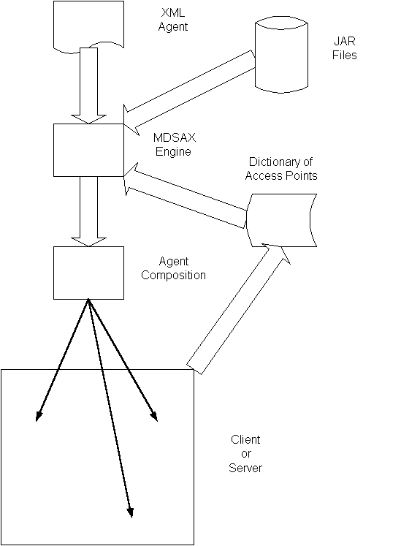
The above diagram shows the composition of an agent by the QUICK engine, using an XML file and a local JAR file. The agent is given access to various parts of the receiving client or server, as specified in the dictionary created by that client or server.
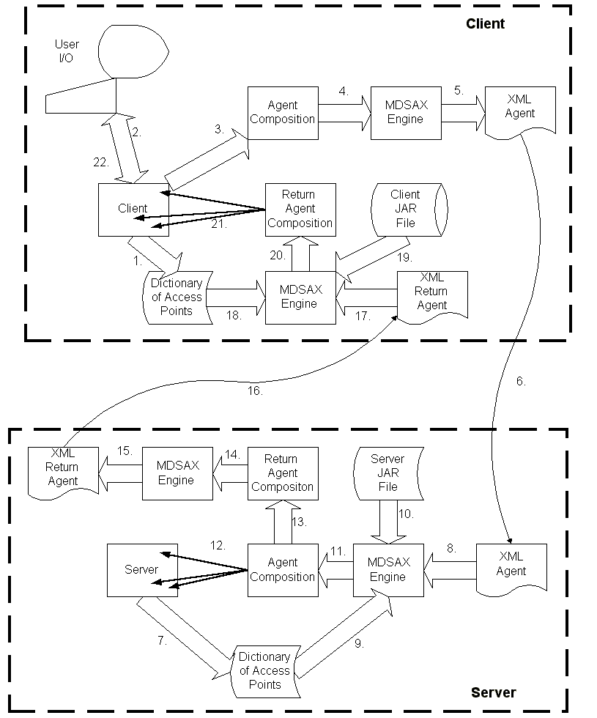
The above diagram shows the interactive creation of an agent, the agent's remote execution, and an update to the display based on the results of that execution, as follows:
- During initialization, the client application establishes various internal points of access to be made available to incoming/returning agents.
- The user interacts with the client application, requesting a remote service.
- The client application defines the remote service request using one or more objects.
- The objects defining the remote service request are passed to the QUICK engine for processing.
- The QUICK engine walks the object graph, extracts selected information, and produces an XML document which describes the intent of the remote service request.
- The XML document is passed from the client system to the server system.
- During initialization, the server application establishes various internal points of access to be made available to incoming/returning agents.
- The XML document is passed to the QUICK engine for processing.
- The QUICK engine inserts references to various parts of the server application into the agent being composed.
- The QUICK engine composes the agent from the server's own classes.
- The QUICK engine passes control to the agent it just created.
- The agent interacts with the server, performing a query, update, or some other operation.
- The agent constructs a response in the form of one or more objects.
- The objects defining the response are passed to the QUICK engine for processing.
- The QUICK engine walks the object graph, extracts selected information, and produces an XML document that describes the returning agent.
- The XML document is passed from the server system back to the client system.
- The XML document is passed to the QUICK engine for processing.
- The QUICK engine inserts references to various parts of the client application into the agent being composed.
- The QUICK engine composes the agent from the client's own classes.
- The QUICK engine passes control to the agent it just created.
- The agent interacts with the client, updating the client with the results of the remote operation.
- The user's display is updated appropriately.

Appendix B - Demo Description

Intention of demo scenario
The demo is intended to illustrate certain qualities of the Quick technology, specifically:
- that a server that accepts agents can performs a simple query or update and then sends an agent back to the originator (or initiator) with the response.
- that a client which launches agents in response to various informational needs can updates its display appropriately as agents are received as a response.
- that incoming agents can augment an active GUI when new information or resources become available.
- that the agent platform validates the fields, data, and structure of the agent documents
- that agents to include access to external data

Nature of the problem
To illustrate these qualities a very limited generic UNIX remote process-monitoring tool has been developed that is top or ps like. Programs such as top and ps must have some way to obtain information from the kernel about processes and system resources. Similarly other tools need the ability to control and inspect a running process. This is generally provided by a variety of interfaces. These interfaces are generally machine-specific and tied to a particular kernel design. To illustrate, in order for the ps command to list a table of information on all running processes it must transverse many directories and files of the /proc filesystem. The implication of the /proc filesystem under the many flavors of UNIX and UNIX like systems are very different thus requiring a distinct implementation of the ps command for each platform type. There is currently no universally accepted interface for this kind of process-kernel interaction thus allowing a generic process monitoring tool that is platform independent and capable of remote operation in a distributed environment.
The development of a remote process-monitoring tool using QUICK technology would allow us too remotely monitor an unspecified (but supported) platform type. This process-monitoring tool will create and transmit an agent-of-intent to the targeted (or intended responding) node. The composition of the agent on the targeted (or responding) node would be platform dependent and assembled from components for that platform type but generic to the initiating (or requesting) node thus hiding the implements details from the initiator. The agent on the targeted (or responding) node after completing its operation would transmit an agent-of-intent back to the initiating (or requesting) node with the data. From the returned agent-of-intent an agent will be composed from components on and supporting the initiating node. This agent will generate the appropriate GUI display consistent with the requirements of the platform type and the data returned. Note that neither the initiating node nor the responding nodes have any platform knowledge of the other.

Testbed configuration
The demo scenario is a two node configuration with Windows 2000 as thee initiating (or requesting) node and RH Linux 6.2 as the targeted (or responding) node. Our testbed consists of a single Dell Optiplex 2-way SMP (Pentium Pro 200) platform with 128MB and multi-head support (two video displays). The system has been configured with Windows 2000 as the “host” operating system but utilizes Vmware to support RH 6.2 Linux as a virtual “guest” operating system. This allows us to support multiple OS types and configurations with limited hardware requirements. This also eases transportability issues of the testbed. (We hope to eventually port this testbed configuration to a laptop.) Vmware supplies a virtual network between the “host” and “guest” operating systems. Of the available 128 MB of memory, 64 MB of memory has been dedicated each to the “host” and “guest” operating systems. Both the “host” and “guest” operating systems have a Java Web Server (JSDK2.1) that supports the http protocol between the two nodes.

Appendix C - Report on the Feasibility of Composable Agents
By Bill la Forge, Principal Investigator
July 9th, 2000
XML is a minor innovation—use of a uniform syntax for structure, while allowing for custom tags to identify application-specific content. At the same time, XML is a disruptive technology, as it enables the development of new kinds of generic tools for processing data. These tools depend on the uniform syntax of XML for structure, while allowing for the configuration of content processing based on tag name.
XML has come to be broadly accepted as the best form for on-line data exchanges, in spite of its verbosity. Indeed, standards organizations such as The Open Group now mandate that any non-XML standard proposal must include a justification of why XML was not used.
But while XML is viewed as the best form for data exchanges, there is a lack of appropriate technology for processing that XML. Current practice typically involves conversion of XML into a Document Object Model (DOM), which is a tree of objects representing the XML document, and then writing code to navigate the tree to extract the content. The problem here is that the tag names (and expected content of various elements) used in the data exchange are embedded in the application code which navigates the DOM. This tree navigation code is often difficult to understand, resulting in high Total Cost of Ownership (TCO) as the tags and element content models change.
One solution here is to use a composition tool to convert XML documents into trees of application-specific objects, and then treat the result as an agent of the author of the document. This largely eliminates the need for any tree navigation code, while cleanly removing tag names from the code. The code is easier to understand and the TCO is much lower.
This brings us to the question, is this a feasible approach? It’s a matter of tool availability and programmability:
There are a number of tools available which use a technology alternately called either XML Data-Binding or Schema Compiling. Tools based on this technology can be used to convert XML documents into a composition of objects which can perform as an agent. The drawback to using this technology is that the instantiated objects must all be based on classes derived from code generated by these tools from a particular XML schema or DTD, which adds a bit of awkwardness at times when a pre-existing class would be a better choice. So we characterize tools based on this technology as supporting restrained composition.
An Open Source product, Quick, has been developed as part of this project to allow for the use of pre-existing classes. It depends on the use of a binding schema to map XML into structures of objects. Adoption has not been wide-spread, with the binding schema somewhat difficult to learn, though easy enough to use.
The use of agents itself requires a change in programming paradigm, and such changes are slow at best.
Is it feasible to use agent composition as a means of processing XML? Availability of tools does not appear to be an issue. The next generation of XML Data-Binding is expected to give greater control over the choice of data representation, and Quick is expected to become easier to learn as well.
The issue then is with using agents at all. These are agents composed from incoming XML documents, where the agent then acts “in proxy” for the author of the XML document who requested some service.
For programmers familiar with neither composition nor agents, this will require a considerable change in perspective. Fortunately, it is possible to make some small steps. A first step would be to transform all content below the root element of the document into simple “data objects”, which only have methods for accessing content, with all application logic placed on the object which corresponds to the root element of the incoming document. This is not a difficult change, as it is simply a matter of moving the application logic a little closer to the data. The down side is that there will still be navigational logic for pulling content from sub-trees, but as the programmer becomes familiar with this new approach, more and more of the processing logic will naturally migrate to be closer to the data—a simple matter of good object design with a clear win in the elimination of navigational logic.
The conclusion then is that even the change in programming paradigm is not a difficult one, so long as the programmer is familiar already with Object Oriented Programming. Composable Agents is a feasible approach to processing XML in on-line data exchanges.

Appendix D - Report on the Feasibility of Validation of Agents for Trustability

By Bill la Forge
July 15th, 2000

Trust plays a central role in any on-line service—can the owner of the service trust the other party to do no harm? But when services are offered on the internet, it is the service which must be trusted not to accept any potentially harmful request.
On-line services take three general forms: messages, RPC/RMI, and agents. Message-based services are the safest, but the least flexible. Messages have a fixed syntax, allowing them to be parsed and validated prior to their being processed by business logic. This significantly increases the trustworthiness of the service, as it prevents the processing of requests which contain unexpected data. But the fixed syntax limits flexibility. And when scaled to the world-wide web, it is difficult to change the syntax.
RPC/RMI-based services provide a remote system with access to the API of a local business process. This eliminates the need to design a message syntax, but makes the server less trustworthy, as the business logic becomes responsible for validating the data being passed. CORBA-based services do use a schema (IDL) for doing some of the validation, but services based on Java’s RMI have greater flexibility, while allowing code to be passed transparently by subclassing the parameter types, and consequently carries a greater risk of abuse.
Agent-based services provide by far the greatest flexibility, allowing services requestors to attach their own code to the server. And since it is not possible to validate that code on-line, these services are the least trustworthy.
XML is now almost a requirement for all new internet services. XML has the advantage of providing a very rich syntax for complex data, and extensible tagging of content. The obvious conclusion is that XML-based services are simply a more flexible form of message-based service, where service requests are parsed and validated prior to processing. And that validation of requests should make such services quite trustworthy. Unfortunately, there are a few complications:
Part of the specification of XML included the definition of validation. An XML document is validated against the DTD (or schema) provided by the author of the document. The document may also contain extensions to the DTD. This means that a document is considered valid when it meets the expectations of the author. So parsing and validating an XML document provides little assurance that the document conforms to the requirements of the service which received that document. This kind of validation may be acceptable when the users of a service are trustworthy, but is not helpful for internet services when the service must protect itself from abuse.
Microsoft’s SOAP provides a means of encoding RPCs in XML. This includes the serialization of parameters in a form which can not be validated against a schema, placing the burden of validation on the business logic of the service.
To assure the trustworthiness of XML-based internet services then, validation of the incoming requests must be made against schema specified by the service itself, and that validation should occur prior to the invocation of the business logic. The use of XML itself provides no assurance that a service can provide adequately robust protection against incorrectly processing invalid requests.
The XML Agents system developed in this SBIR validates incoming requests, so that services built on this system can be trusted not to accept any potentially harmful request. Normally when agents are passed as service requests, code is attached to the server, making it impossible to determine if the request is harmful. XML Agents use XML documents as requests, where these documents direct the composition and configuration of objects to construct the active form of the agent on the server, using only code that has been provided by the server for use in such compositions. Further, the documents which define the requests must conform to the binding schema provided by the server. These binding schema specify the overall document structure, how the data content is to be validated, and the code which various tags are to be mapped to.
XML Agents may be less flexible than ordinary agents, but are still considerably more flexible than an PRC/RMI system, while providing the trustworthiness normally only found in a message-based system.

